1. Provide a screenshot to show that you successfully installed DASK.

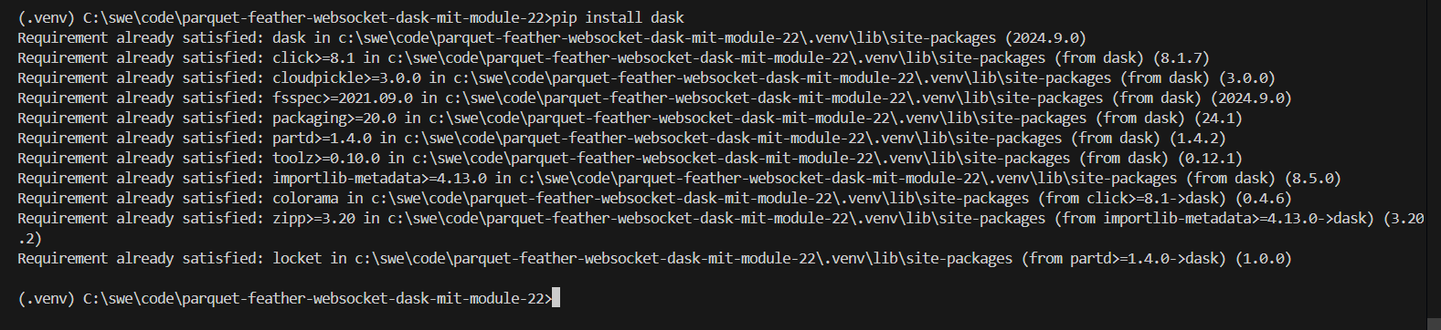

1. Provide a screenshot to show that you opened the file correctly.

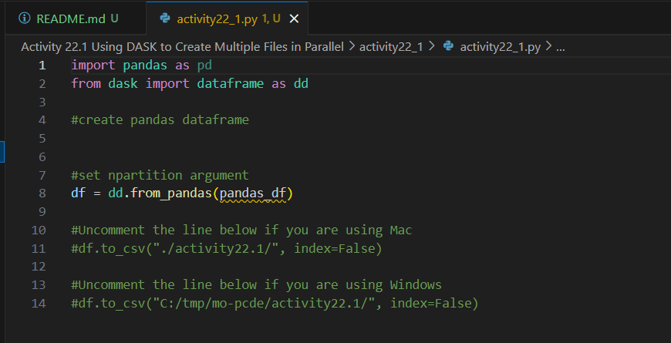

1. Provide a screenshot to show that you created the pandas_df *dataframe* correctly.



1. Provide a screenshot to show that you set the npartitions *argument* equal to 2.

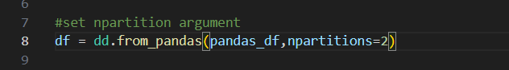

1. Provide a screenshot to show that you ran the code without any errors.

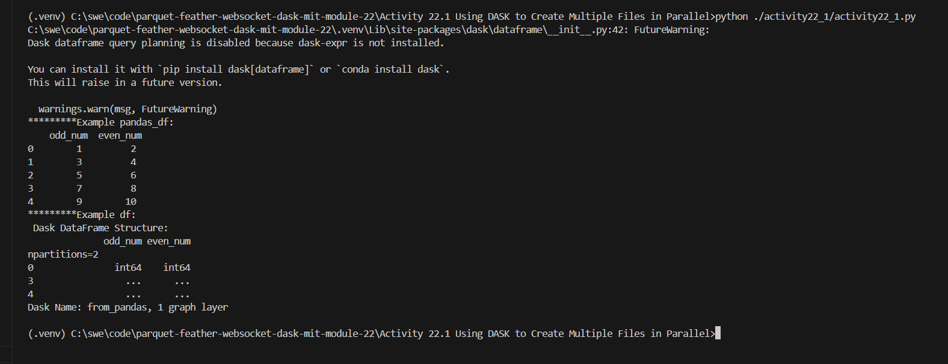

1. Provide a screenshot to show that the 0.part and 1.part files are present inside of the activity22.1 folder.

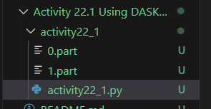

1. Provide two screenshots. The first screenshot should show the contents of the 0.part file. The second screenshot should show the contents of the 1.part file.



